Stretches for Quads, Hamstrings, Calf
Stretches should be done 2-4 reps and held from 15-30 seconds.

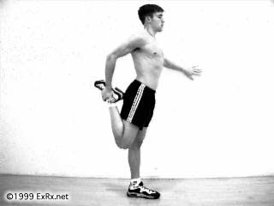
Stand and touch wall or stationary object for balance. Grasp top ankle or forefoot behind. Pull ankle or forefoot to rear end. Straighten hip by moving knee backward. Hold stretch. Repeat with opposite side.

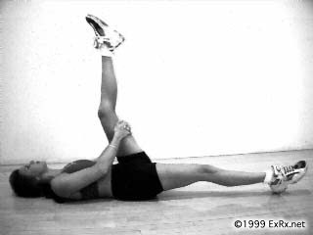

Lie on back and lift knee up. Grasp behind thigh near knee with both hands. Pull knee close to chest. Extend knee while maintaining knee close to chest. Hold stretch. Repeat with opposite leg.

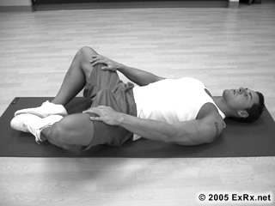
Lie on floor or mat. Place soles of feet together on floor close to body with knees far apart. Lower knees toward floor. Hold stretch.

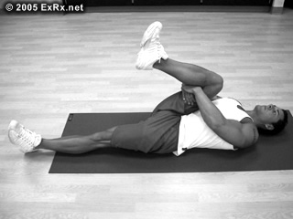
Lie supine on floor or mat. Raise knees and grasp back of thighs behind knees.
Pull knee toward shoulders or to side of torso while keeping opposite leg on floor. Hold stretch.

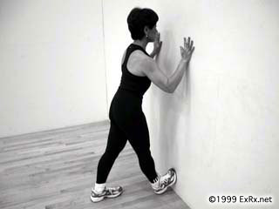
Face wall with both knees slightly bent. Position fore foot on wall with heel on floor. Straighten knees and lean body toward wall. Hold stretch . Repeat with opposite leg.

Place both hands on wall with arms extended. Lean against wall with one leg bent forward and other leg extended back with knee straight and foot positioned directly forward.
Push rear heal to floor and move hips slightly forward. Hold stretch. Repeat with opposite leg.

Arm Stretches

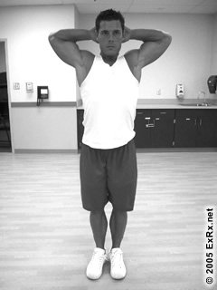
Place hands behind head.
Pull elbows back further behind ears. Hold stretch.

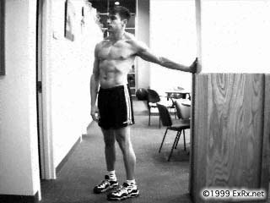
Stand at end of wall or in doorway facing perpendicular to wall. Position palm on surface of wall slightly lower than shoulder. Bend elbow slightly.
Turn body away from positioned arm. Hold stretch. Repeat with opposite arm.

Put one arm overhead. Position forearm as close as possible to upper arm. Grasp elbow overhead with other hand.
Pull elbow back and toward head. Hold stretch. Repeat with opposite arm.

